Assignmet 38.
- What is alv and use of alv?
- ALV – ABAP List Viewer
- It is a STANDARD SAP tool to display internal table data in a professional, interactive format with built-in features like sorting, filtering, totals, export to Excel etc.
- Types:
- 1.ALV List Display (Function Module):-
- This is the oldest form of ALV and is list-based, similar to traditional WRITE statements. It offers basic functionality like sorting and totals, but has limited interactivity.
- Common FM: REUSE_ALV_LIST_DISPLAY
- 2. ALV Grid Display (Function Module):-
- Grid ALV is control-based and much more powerful. It supports editable cells, F4 help, dropdowns, filtering, sorting, and layout saving.
- Common FM: REUSE_ALV_GRID_DISPLAY_LVC
- 3. OO ALV (Object-Oriented ALV):-
- OO ALV provides full flexibility using classes and event handling. It is ideal for complex and interactive reporting requirements and is considered a best practice for advanced scenarios.
- Main Class: CL_GUI_ALV_GRID
- 4. SALV (Simple ALV):-
- SALV is a lightweight OO ALV designed for quick and clean reports. It requires minimal code but offers limited customization and is mostly read-only.
- Main Class: CL_SALV_TABLE
- ALV (ABAP List Viewer) is a SAP reporting tool used to display data in a tabular format with features like sorting, filtering, searching, totals, printing, and Excel export. The main types of ALV are ALV List Display, ALV Grid Display, OO ALV, and SALV.

- Which Function Modules are used in ALV?
- 1. REUSE_ALV_LIST_DISPLAY
- Used to display data in List Display format
- 2. REUSE_ALV_GRID_DISPLAY
- Used to display data in Grid Display format.
- Ex:- CALL FUNCTION 'REUSE_ALV_GRID_DISPLAY'
- EXPORTING
- it_fieldcat = lt_fieldcat
- TABLES
- t_outtab = lt_mara.
- The commonly used Function Modules in ALV are REUSE_ALV_LIST_DISPLAY and REUSE_ALV_GRID_DISPLAY. Among them, REUSE_ALV_GRID_DISPLAY is the most widely used because it provides an interactive grid with features like sorting, filtering, layouts, totals, and Excel export.

- Difference between List Display and Grid Display.
List Display | Grid Display
- Uses REUSE_ALV_LIST_DISPLAY | - Uses REUSE_ALV_GRID_DISPLAY
- Displays output in list format | - Displays output in grid format
- Limited user interaction | - Highly interactive
- Limited features | - Supports sorting, filtering, totals, layouts, Excel export
- Older technology | - More commonly used in projects

- What is Field Catalogue?
- A Field Catalogue is an internal table that contains the metadata for each column in an ALV report.
- A Field Catalogue is an internal table that stores the properties of each column in an ALV report, such as field name, column heading, output length, key field, editability, hotspot, and totals. It controls the appearance and behavior of the ALV output.

- Important Fields in the Field Catalogue.
- Field | Purpose
FIELDNAME | Name of the field from the internal table
TABNAME | Internal table name
COL_POS | Position of the column
COLTEXT | Column heading
SELTEXT_M | Medium-length column heading
OUTPUTLEN | Width of the column
KEY | Marks the column as a key field
EDIT | Makes the column editable
HOTSPOT | Makes the column clickable
DO_SUM | Displays totals for numeric fields
CHECKBOX | Displays the field as a checkbox
NO_ZERO | Hides zero values
JUST | Aligns the data (Left, Center, Right)
EMPHASIZE | Highlights the column with color
ICON | Displays an icon instead of text

- what are the types of function module used in alv to display the output format?
- 1.REUSE_ALV_LIST_DISPLAY
- Output is similar to a classical report.
- Supports sorting, filtering, totals, and printing.
- Limited interaction compared to Grid Display.
- Ex: CALL FUNCTION 'REUSE_ALV_LIST_DISPLAY'
EXPORTING
it_fieldcat = lt_fieldcat
TABLES
t_outtab = lt_data.

- 2.REUSE_ALV_GRID_DISPLAY
- Displays the ALV output in Grid Display format.
- Features:
- Interactive grid output, Sorting, Filtering, Totals/Subtotals, Excel Export, Save Layout, Hotspot, Events, Better user interface
- Ex: CALL FUNCTION 'REUSE_ALV_GRID_DISPLAY'
EXPORTING
it_fieldcat = lt_fieldcat
TABLES
t_outtab = lt_data.

- Create alv report to display the purchase order details in list format?
- 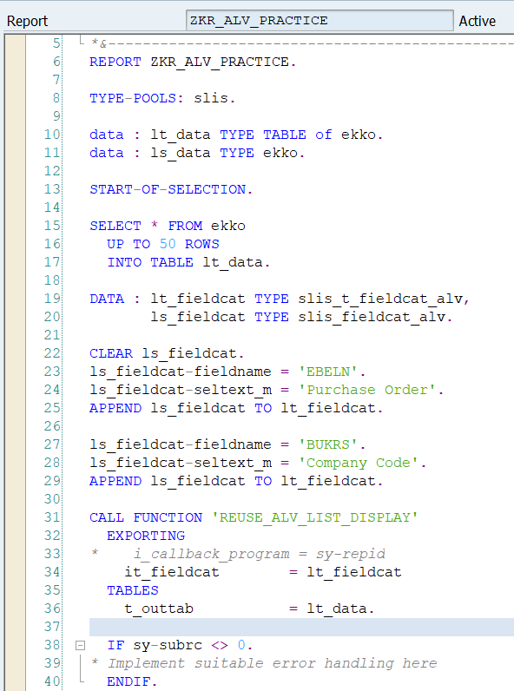
- Output: upto 50 rows
- 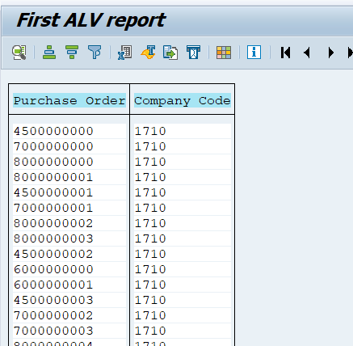
- Create alv report to display the sales order details in grid format?
- 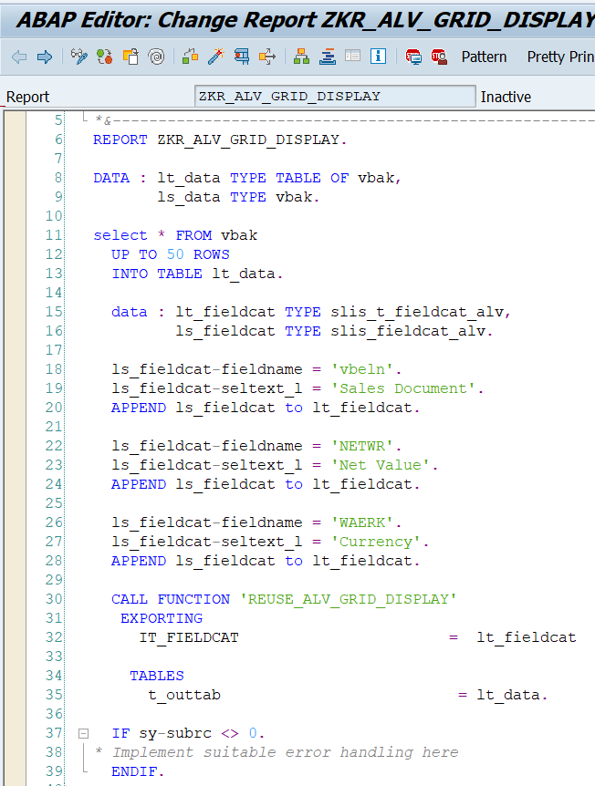
- Output: upto 50 rows
- 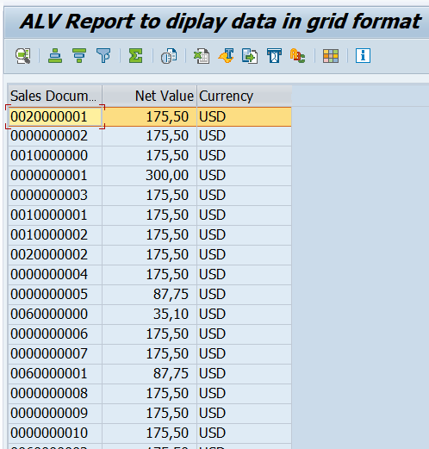
- Create alv report to fetch the data(using some particular fields) by using mara and marc in grid format?
- Using Inner join because both tables are related by MATNR (Material Number).
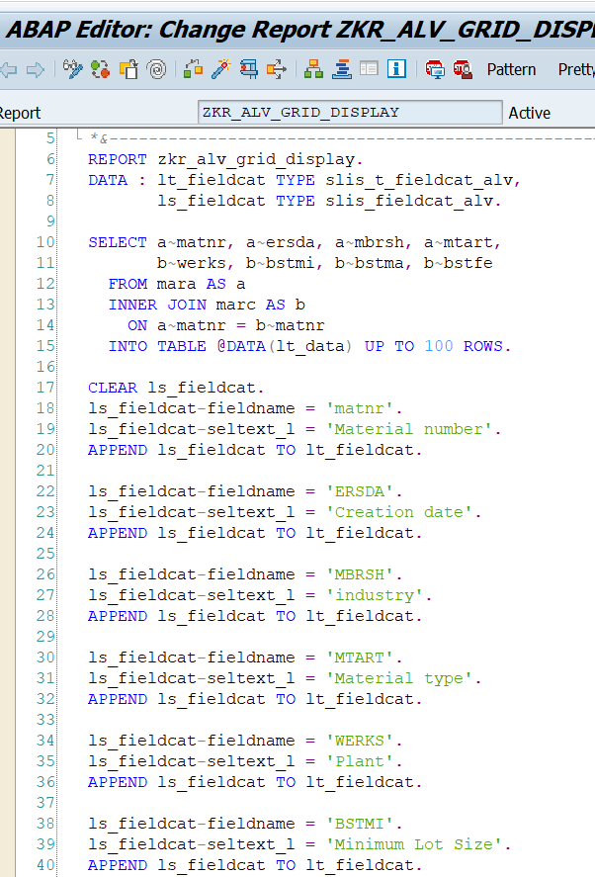
- 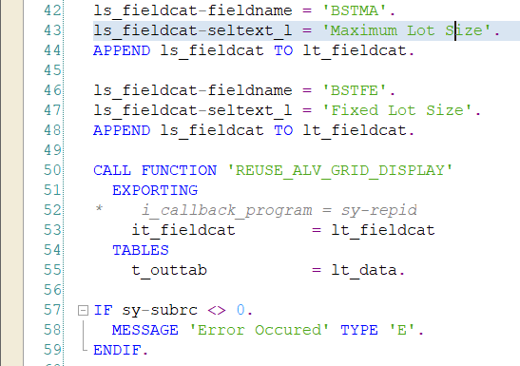
- Output: upto 100 rows
- 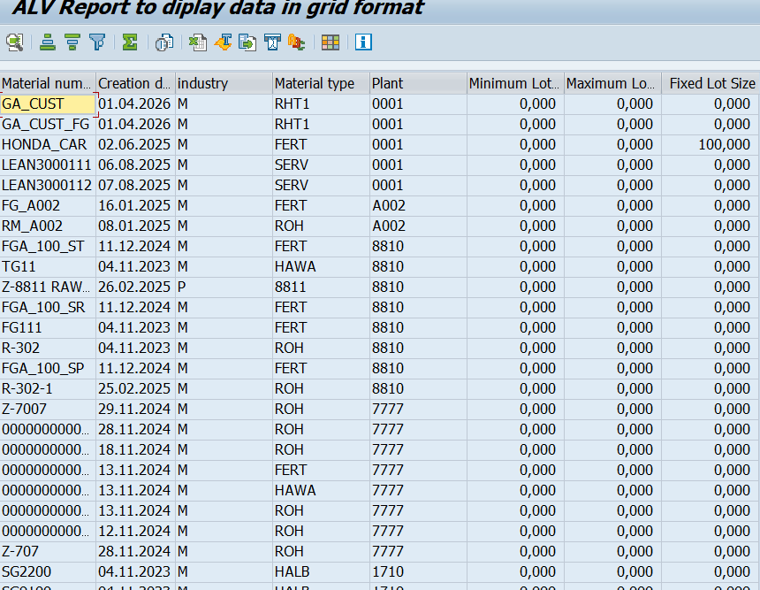

- Explain the difference between classical,interactive and alv?
Classical Report | Interactive Report | ALV Report
Displays data using WRITE statements. | Displays summary data first and detailed data on user interaction (double-click). | Displays data in a professional tabular format with built-in features.
No drill-down functionality. | Supports drill-down using double-click. | Supports sorting, filtering, totals, Excel export, layouts, etc.
User cannot interact with the report. | User interacts by selecting a line or command. | User can sort, filter, search, print, export, and customize the report.
Uses classical report events. | Uses classical + interactive report events. | Uses ALV Function Modules or Classes.
Output generated using WRITE. | Output generated using WRITE with HIDE, AT LINE-SELECTION, etc. | Output generated using REUSE_ALV_GRID_DISPLAY, REUSE_ALV_LIST_DISPLAY, or ALV classes.
More coding required for additional features. | More coding required for drill-down logic. | Less coding because SAP provides built-in functionalities.
- Explain the diffrence between List and Grid display?
List Display | Grid Display
Uses the Function Module REUSE_ALV_LIST_DISPLAY. | Uses the Function Module REUSE_ALV_GRID_DISPLAY.
Displays data in a simple list format similar to a classical report. | Displays data in a tabular grid format.
Provides basic ALV functionalities. | Provides advanced interactive functionalities.
Limited user interaction. | Highly interactive and user-friendly.
Does not support editable cells. | Supports editable cells (with additional settings).
Older ALV technology. | More commonly used in real-time projects.
Suitable for simple reports. | Suitable for complex and interactive reports.

- List Display presents the report in a simple list format using the Function Module: REUSE_ALV_LIST_DISPLAY
- Grid Display presents the report in an interactive grid format using the Function Module: REUSE_ALV_GRID_DISPLAY

- Create alv report using field catlog of material table?
- From MARA table:
- 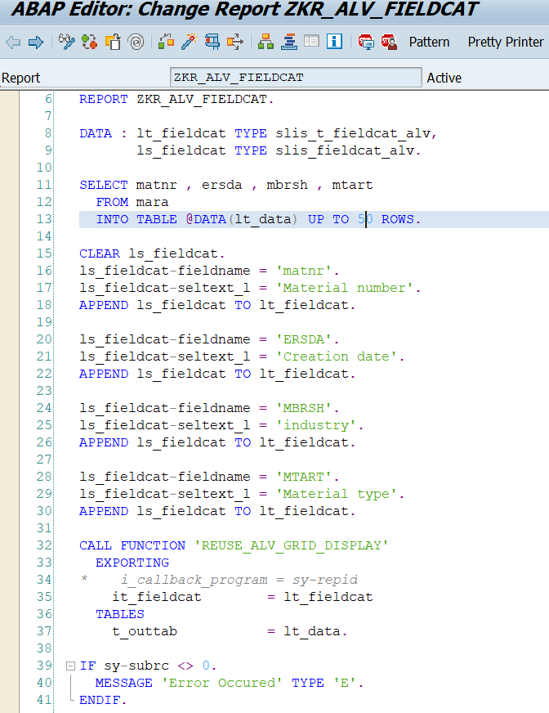
- Output: 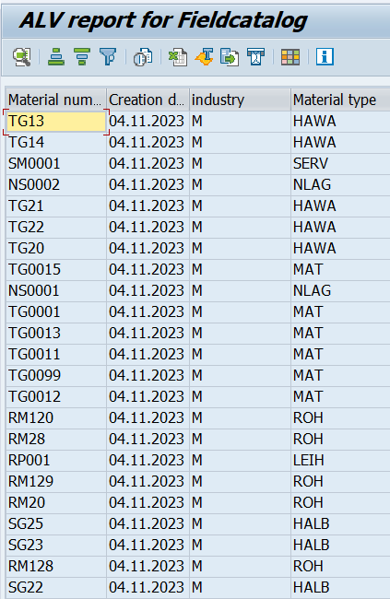

- Create an alv report for billing document details to display data in grid format and using layout how to achieve column optimization, edit, no vertical, no hrizontal and hotspot.
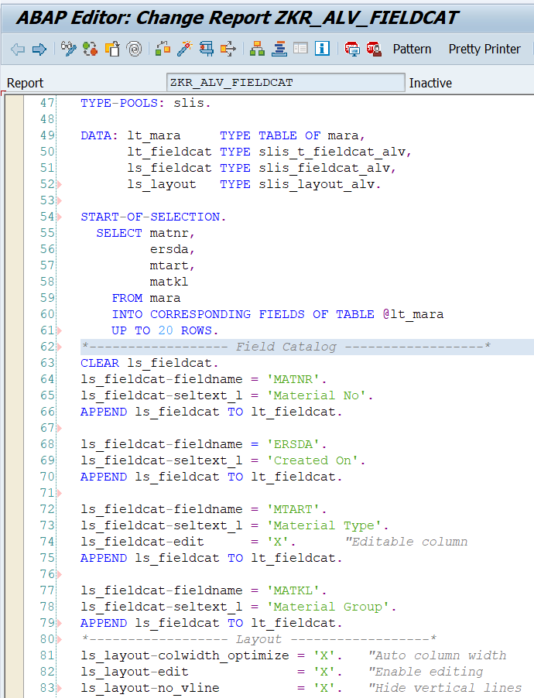
- 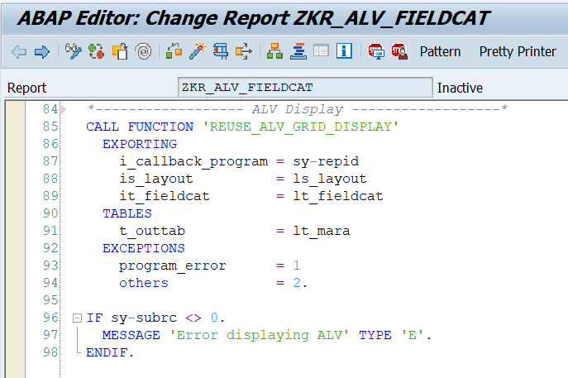
- Output:
- Before edit:
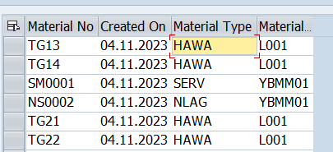
- After edit:
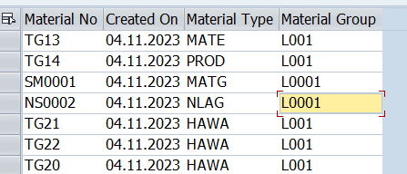

- Create an alv report for spfli table for total and subtotal?

